Castro Andre Thomas Liquido Laboratory Exercise 3

BSCS-3A Prof:Arlene Evangelista

Take a screenshot of the maximized Task Manager window that shoes five (5) columns listed above. Analyze the details of the running processes in your computer. You may open other columns that would show additional details regarding each process.Then explain the relationships or Inter-dependencies that you can conclude based on the corresponding details in your Task Manager.

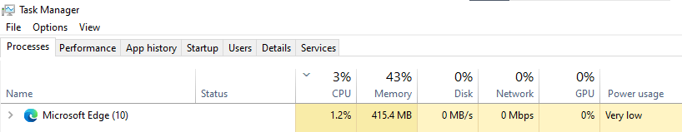

Answer: In this Example I open an Application called Microsoft Edge as you can see in here it pop ups in front of the task that is Having a Process as you can see the **CPU** usage is an Average of 3% witch means I open a minimal tabs because the high percentage indicates that the process is using a significant portion CPU's processing power.

The **Memory** column consumes an average RAM process of 43% which means the process is currently using and the browser is currently Consuming 415.4MB storage

The **Disk** Column Display the current read and write of the data in this example it shows 0% Network which means the rate data transfer is measured in bytes per second

The  **Network** column shows 0% which means the amount of network bandwidth used by the process is labeled as small actively transferring of data it means that the amount of data being sent and received over the network is relatively small. Processes with low network usage are not actively transferring a significant amount of data.

The **GPU** Column indicates that the dedicated graphics card, the GPU tab will show information about GPU usage and performance in this example as you can see its 0% witch means it utilization for both the graphics engine and memory.

And for the last Column for **Power Usage** it shows that the Text”very low ” which indicates the amount of power consumption

The CPU, Memory, Disk, Network, GPU, and Power Usage columns in Task Manager each indicate a distinct aspect of my computer's performance. Recognizing the connections between these columns will assist you in troubleshooting, tracking resource consumption, and improving system efficiency. You can also monitor resource usage and optimize system performance .